

**CSR POLICY**

**‘A SUSTAINABLE WORLD STARTS WITH US’**

# COMMITMENT

Driven by our vision, mission and values, we are constantly contributing to a sustainable world. Through a well-considered and supported CSR policy (Corporate Social Responsibility), we aim to increase our positive impact on people, environment and society step-by-step. Our commitment to make progress in all our activities stems from UN Sustainable Development Goals helps us. We report on our efforts in line with the Global Reporting Initiative.

# targets

**People - 'We strive for a sustainable and inclusive work environment'**

Our employees are key to our success. We invest in them by creating development opportunities within a safe and respectful work environment. In addition, we want to take our responsibility to promote our own labour and human rights standards throughout our value chain.

Jan De Nul Group has defined 4 focus areas to create this sustainable work environment:

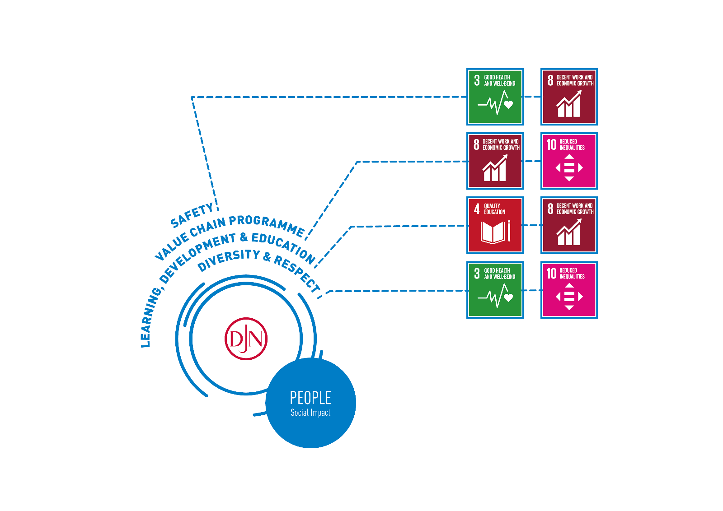

* Safety: We are committed to creating a safe work environment for all employees involved in our activities, with due attention to physical and mental health.
* Value Chain Programme: As a global player, we recognise our responsibility to protect and promote labour and human rights throughout our value chain.
* Learning, development & education: We give our (future) employees good development opportunities in their work in view of their personal development and the company’s sustainable growth.
* Diversity & respect: Working together in a positive, connecting and respectful way guarantees qualitative projects. We are committed to taking action against all forms of discrimination.

**Planet – 'We are constantly reducing our ecological footprint”**

Our planet is under pressure and we feel closely involved. We will improve our environmental performance step by step out of respect for nature, our living environment and public health.

Jan De Nul Group has defined 4 focus areas to reduce our ecological footprint:

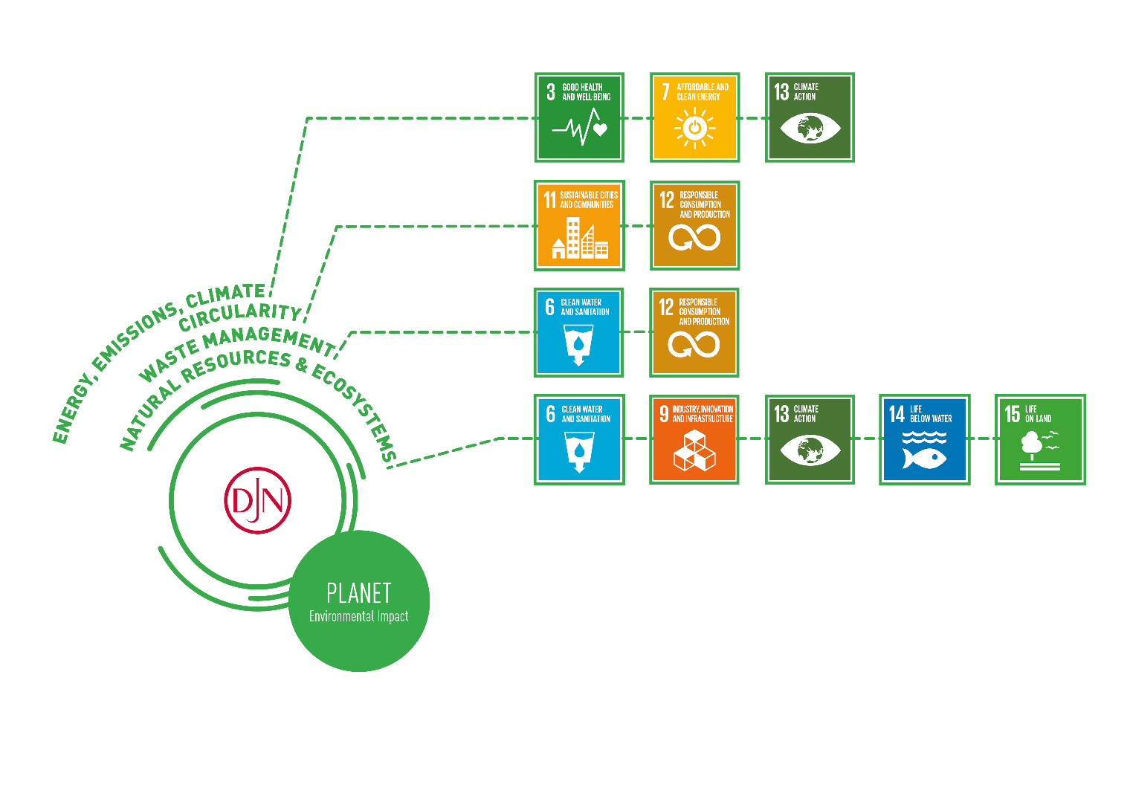

* Energy, emissions, climate: the challenges in the field of energy consumption, emissions and climate are the perfect engine for innovation. By introducing emission-reducing measures and by promoting energy efficiency, we combat climate change and contribute to good air quality.
* Circularity: We opt for sustainable consumption and production through investigating and exploring how and where we can implement circular thinking and actions in our activities.
* Waste management: we continue to improve our selective processing of waste and to reduce our waste output overall. We reduce our use of plastic wherever possible as these pose a major threat to the rich marine biodiversity.
* Natural resources & ecosystems: we always manage the environmental aspects of our projects and look for innovative solutions to preserve and improve nature.

**Profit – 'We stand for sustainable business operations”**

A healthy financial situation is our starting point for pursuing sustainable business operations. We apply the highest ethical business standards and expect the same from all our stakeholders. We are contribute to the development of the local communities in which we operate.

Jan De Nul Group has defined 3 focus areas to ensure sustainable business operations:

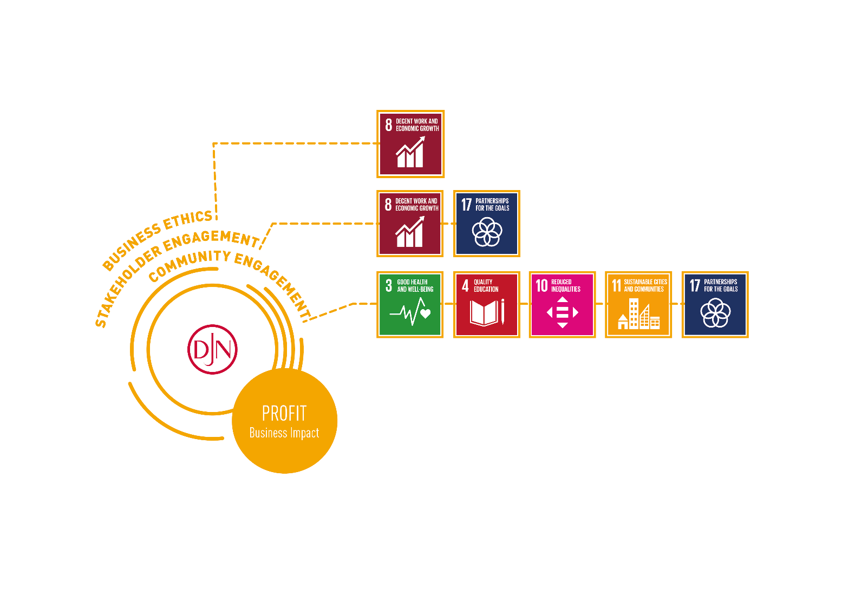

* Business ethics: we maintain the highest ethical standards, in line with all applicable laws and guidelines. We expect our employees and business partners to do the same.
* Stakeholder commitment: partnerships and joint commitments with stakeholders result in more innovation, improved risk management and an increased sphere of influence.
* Commitment towards local communities: we involve local communities in order to support their social, ecological and economic development.

# method

To pursue these ambitions, we commit ourselves to concrete actions, measure our efforts and progress and report on them. We inform our employees and stakeholders about the chosen strategy and our lines of action and support them in their implementation. We expect everyone to be involved in our CSR policy. This is how we are building tomorrow's sustainable world today.

This policy is a living document. Tomorrow's challenges may not be those of today!

# References

* Mission, vision, values (JDN.QF.01.42)
* Code of Conduct Jan De Nul Group (JDN.GF.01.40)
* QHSSE Policy Statement Jan De Nul Group (JDN.QF.01.01)
* Social Accountability Policy Jan De Nul Group(JDN.GF.01.43)